Document A

Letter to the Customs at Boston

Original Transcription
Thomas Rowe worked for the British Customs Service in Salem. He was accused of reporting Salem merchants for attempting to smuggle molasses by secretly removing it from a ship without paying the required duties (taxes). The following day he was attacked by a mob of Salem residents, including. Richard Derby, his son Elias Hasket, and Salem merchant, George Crowninshield.
Page 1
Copy of a Letter from the Collector & Comptroller of Salem and Marblehead to the Commissioners of the Customs at Boston.
Gentlemen,
The Collector was informed this Morning that Cap. Phillip Sanders of the Schooner Neptune lately arrived from Guadeloupe & St. Eustatia who had partly discharged her Cargo, did last Evening about ten o-Clock after the ???? were locked and the Waiter was stepped home to see his Wife, who was very ill, find Means to open the Hatches and land sundry Casks of Molasses but was prevented proceeding any further, by the Waiters return together with the landwaiter. Upon which information the Collector Comptroller Surveyor thought proper this Morning about nine O’Clock to visit the Wharf where the Vessel lay, and inspect into the Matter; when they came there they found themselves surrounded
Page 2
Surrounded by a large Mob with a flag flying, who gave out that they were in pursuit of the person who had given the Information respecting the Landing said Molasses and notwithstanding all the Endeavors of the Officers to quit them, continued to be very riotous for some time; but upon Declaration being made by Mr. Savage the Landwaiter, whom they supposed knew who the Informer was, that he was totally ignorant of the Matter, they went off. Upon which the Principal Officers not thinking it prudent, or consistent with the Good of the Service or their own Safety, to examine any further at that time as to the landing of the Molasses, came up to the Custom house it being then Office Hours; and whilst they were attending their duty, were alarmed by the Appearance of the aforesaid Mob, who had got in the Midst of them mounted in a hand-Cart drawn by some of their party, Thomas Rowe the Tide Waiter, who it seems they were told gave the first Information to Mr. Savage – they had tarred his Clothes all over, and then covered him with feathers, & pinned him into the Cart, and were carrying him thro’ the Town as a Spectacle of Infamy; - Stopping at all the Publick Offices, When they came to the Custom house they were desired
Page 3
Desired to release him, as being an Officer of the Customs and in the Exercise of his Duty, but said they would not till they had done with him, the most they could be prevailed on to do was, to promise they would not hurt him, and after carrying him to the extreme part of the town they released him, at the same time telling him he must not show his face again in this part; - They also stopped in their way at the House of Mr. James Grant late an Officer in the Army, and now employed as a trader in Town, a Gentleman of a respectable Character who they suspected had been an Informer in the Affair of the ???? Cargo from ??? ??? Neddham Master, which was ??? in February last but released by the Honorable Board, but said Gentleman having had Notice of their design against him had withdrawn himself.
Since this Riot and Tumult has subsided the Surveyor and Searcher with the Landwaiter have been down on the Wharf, where the said Master and Owners of the Neptune having before acknowledged that they had landed Nineteen Casks of Molasses in the Night, provided the said Nineteen Casks to those Officers, and have deposited the same in a Warehouse to be forthcoming on Demand. They
Page 4
They are not seized, or under our ????? conceiving it our Duty in this extraordinary Affair to take no further Steps without the Direction of the Honorable Board.
We are with Respect Gentlemen
Your most obedient and faithful Servants.
Signed: J. Fisher Collector
John Mascarene Comptroller
Custom of Salem & Marblehead
7th September 1768

Document A
Page 1
18 cent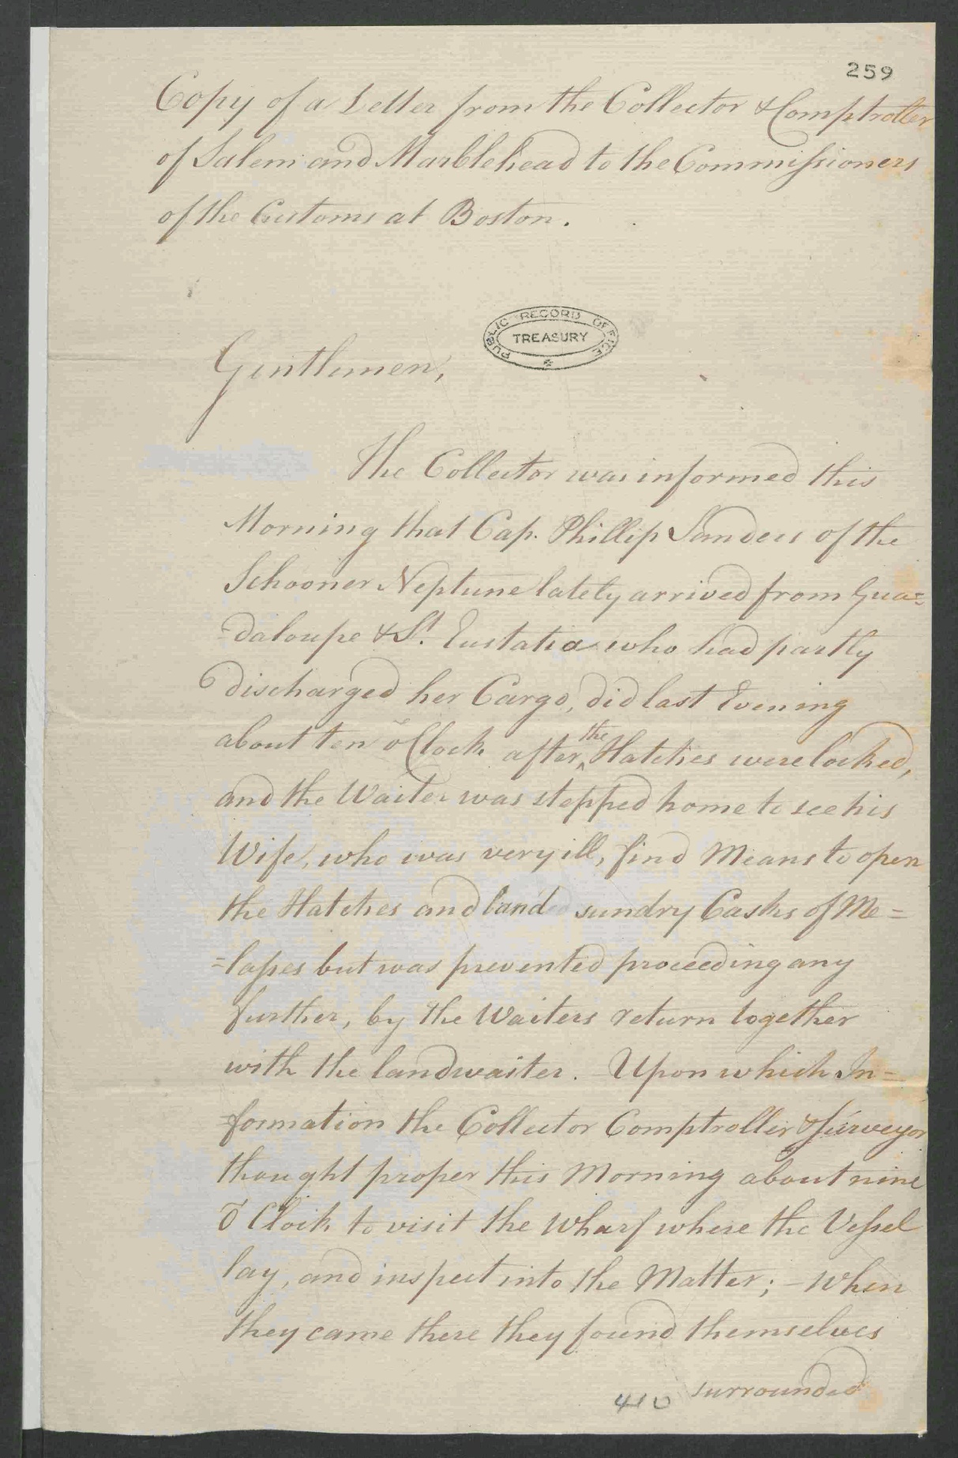

Image Source
The National Archives, United Kingdom. Copy of a Letter from the Collector & Comptroller of Salem and Marblehead to the Commissioners of the Customs at Boston. 1768 Sept. 7. T 1/465/259-260

Document A
Page 2
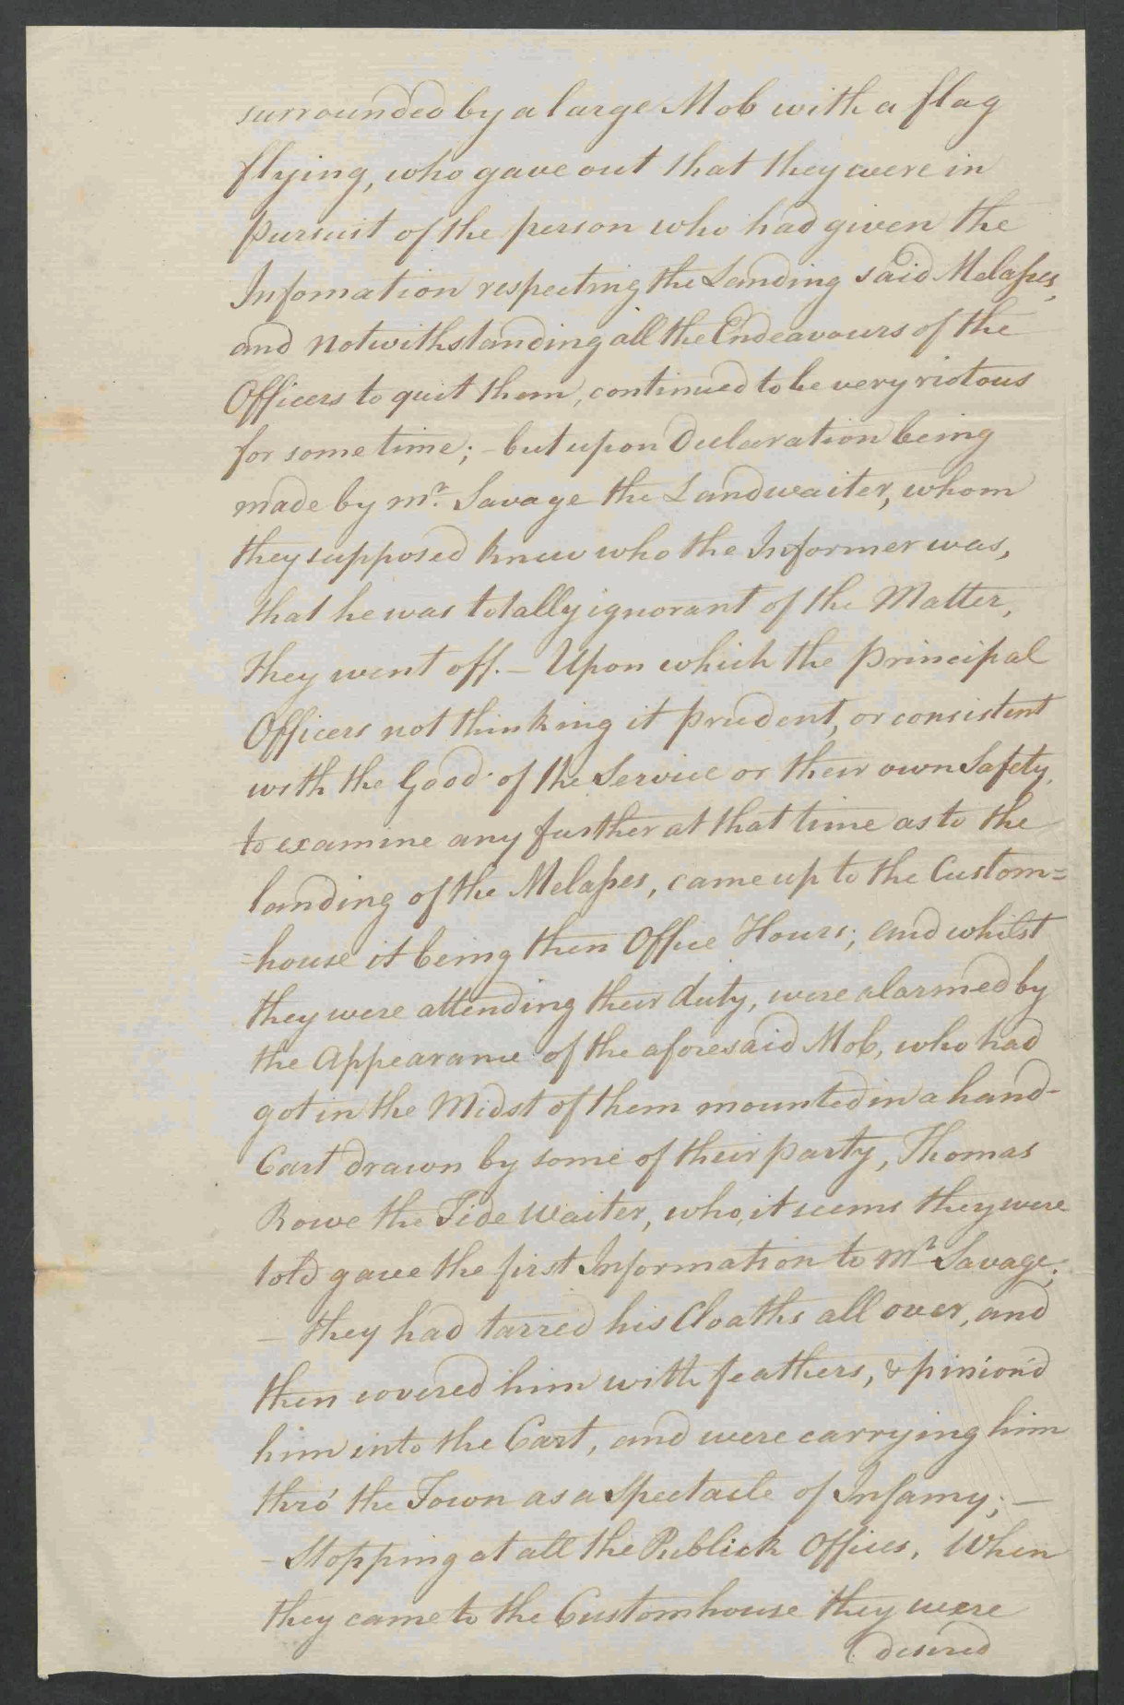

Image Source
The National Archives, United Kingdom. Copy of a Letter from the Collector & Comptroller of Salem and Marblehead to the Commissioners of the Customs at Boston. 1768 Sept. 7. T 1/465/259-260

Document A
Page 3
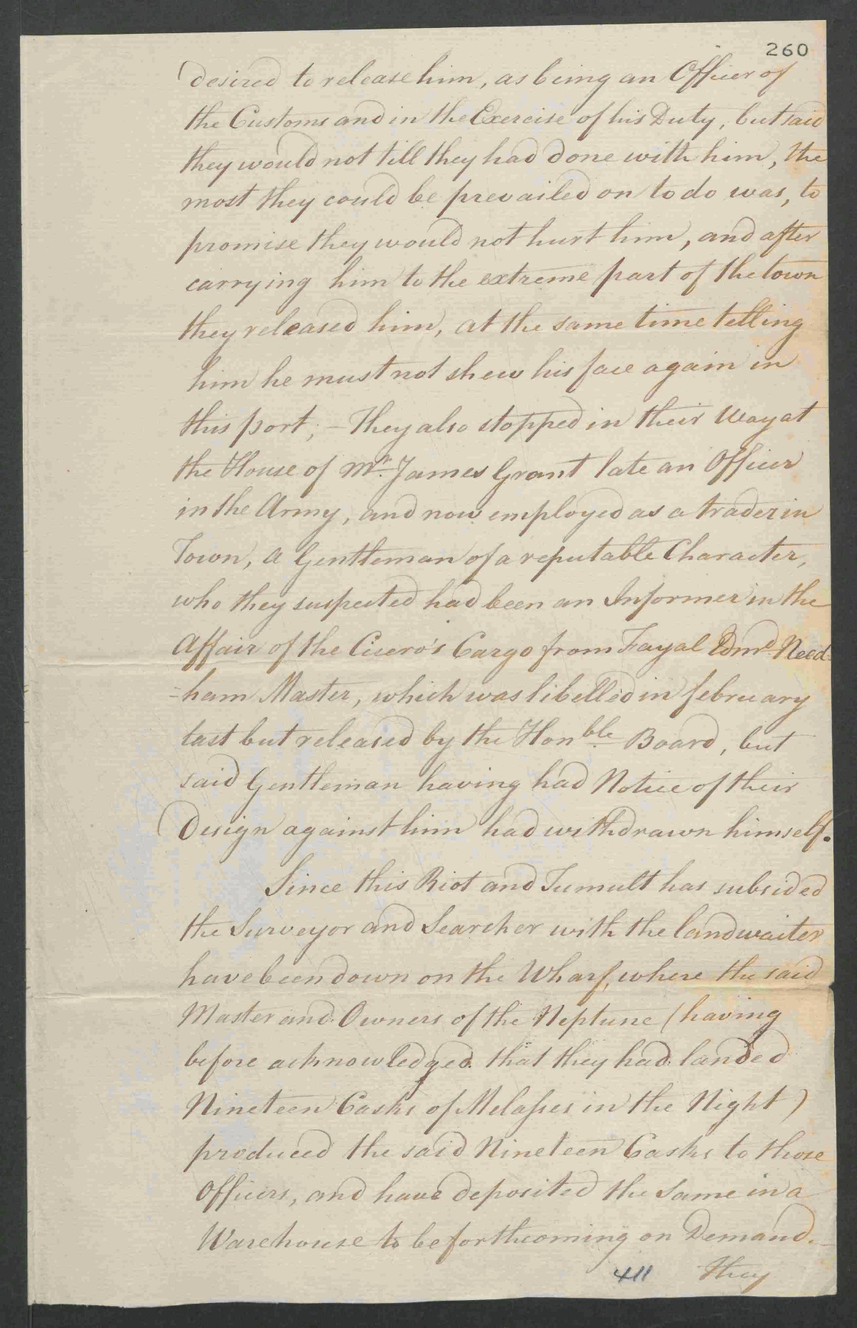

Image Source
The National Archives, United Kingdom. Copy of a Letter from the Collector & Comptroller of Salem and Marblehead to the Commissioners of the Customs at Boston. 1768 Sept. 7. T 1/465/259-260

Document A
Page 4
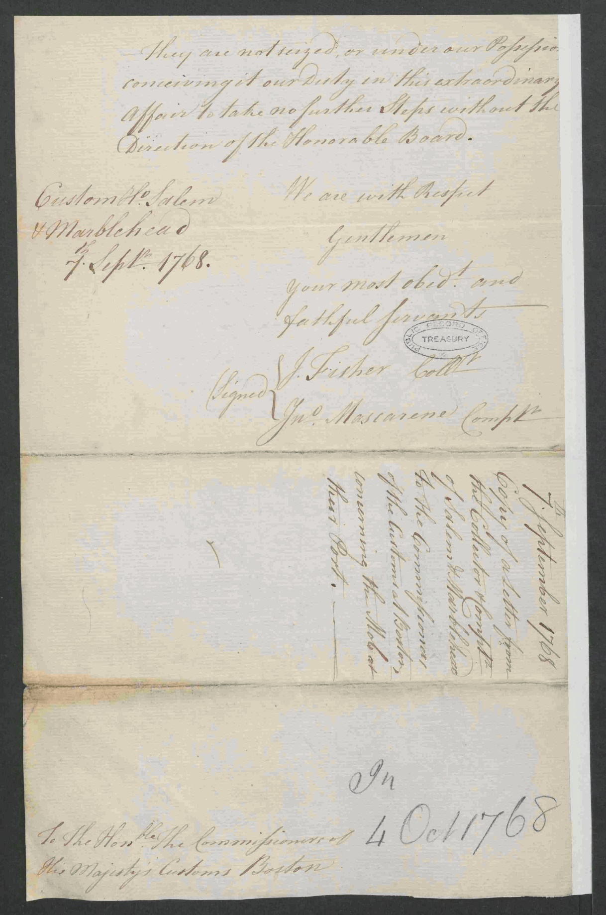

Image Source
The National Archives, United Kingdom. Copy of a Letter from the Collector & Comptroller of Salem and Marblehead to the Commissioners of the Customs at Boston. 1768 Sept. 7. T 1/465/259-260

Document B

Crowninshield Distilling Account with Richard Derby

Original Transcription
Richard Derby was a wealthy ship owner and merchant who traded and sold sugar and molasses from the West Indies. He also owned a Salem distillery where he used molasses to produce rum. This is an account of molasses (right side) used to produce rum (left side) for George Crowninshield, a Salem merchant and ship captain. Crowninshield may have exported this rum across the Atlantic Ocean to Europe or Africa, where it would be traded for enslaved people. It’s also possible he sold this rum locally or in other North American colonies. Note the bottom-left line, accounting for rum delivered by Crowninshield’s enslaved person.

D^{r}: .. .. .. Capt. Geo^{e}: Crowninshield his Distilling Acc^{tt}: with Rich^{d}: Derby .. .. C^{r}:
Left side
1765
Dec^{r}: 13 To.. Ballª: of former Acc^{tt}: in Molass^{s}: . . . . . 280 ¼
1766
July 19 To.. 10 Gallº Rum, 1767 Octo^{r} 6 33 ½ Gallº: Rum ??? 43 1/2
1770
Aug^{t} 17 To.. 17 ½ Gallº Rum d^{d} W. Collins . . . . . . . . 17 ½
To.. 32/34 Gallº: Rum dd^{d}: John Whitton . . . . . 32 ¾
22 To.. 14 h^{d}: Rum 111 Gallº: . . . . . . . . . . . . 111
Dec^{r} 7 To.. 31/34 Gallº: Rum d^{d}: his Servant . . . . 31 ¾
22 To.. 30 H^{d}: Rum ?? 3300 Gallº: . . . . . . 3300 3536 ½
3816 ¾
1771 Jan^{y} To.. 31 ¾ Gallº: Rum d^{d} his Negro . . . . . . 31 ¾
3848 ½
Right side
1766
July 19 By.. Sugar that made 10 Gallº Rum . . . . . . 10
1768
Jan^{y} 1 By.. 212 Gallº: Molas^{s}: of John Prince . . . . . . 212
1770 Nov 22 By.. 1 H^{d} Molas^{s}: 125 Gallº: N^{tt} . . . . . . . 125
Dec^{r}: 11 By.. 3300 Gallº: Molas^{s}: . . . . . . . . . . 3300
3647

Document B

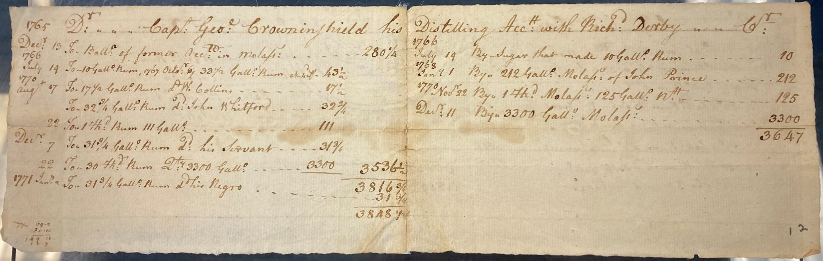

Image Source
MSS 37 Derby Family Papers, Box 16, Folder 1. Philips Library, Peabody Essex Museum, Salem, Mass. NPS Photo.

Supplemental Primary Source Documents

Document C

To Inform All Masters of Vessels
Original Transcription
This notice was placed in The Boston Evening Post newspaper, January 2, 1764. It is “signed” by two officers of the British Customs Service in Salem. The notice directs captains who trade at non-British colonies in the West Indies to pay the required duties on rum, sugar, and molasses. It references the Molasses Act (“Act of the Sixth of his late Majesty King George the Second”), which merchants largely ignored. The Sugar Act was passed three months after this notice was published, on April 5, 1764.

Custom-House
December 26, 1763.
Port of Salem,
Whereas it has been represented
to the Right Honorable the Lords Com-
missioners of his Majesty’s Treasury, that
many Vessels trading to the Plantations not
belonging to the King of Great-Britain, and
returning with Cargoes of Rum, Sugar, and
Molasses, have found Means to smuggle the
same into his Manjesty’s Colonies, without pay-
ing the King’s Duty. This is to inform all
Masters of Vessels using the said Trade, that
they are herby strictly required on their
Arrival here, to enter or report their Ships
and Cargoes at the Custom-House, when pro-
per Officers will be put on board such Vessels,
to see that the Act of the Sixth of his late
Majesty King George the Second (imposing
a Duty on all foreign Rum, Sugar, and Mo-
lasses) be in all it’s Parts fully carried into
Execution.
By Order of the Surveyor-General,
J. Cockle, Collector.
J. Dowse, Surveyor & Searcher

Document C

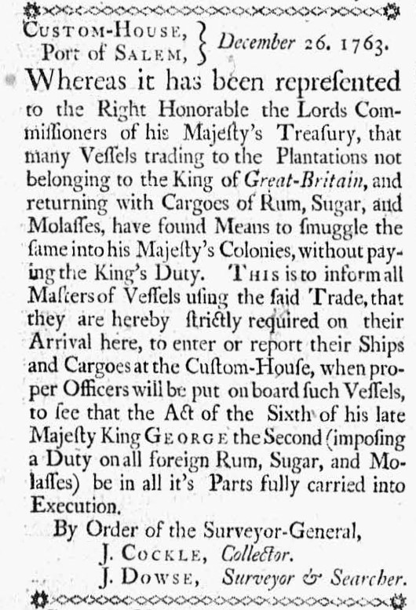

Image Source
“The Boston Evening Post.” January 2, 1774. Courtesy of Readex: America’s Historical Newspapers. Early American Newspapers, Series 1: From Colonies to Nation.

Document C
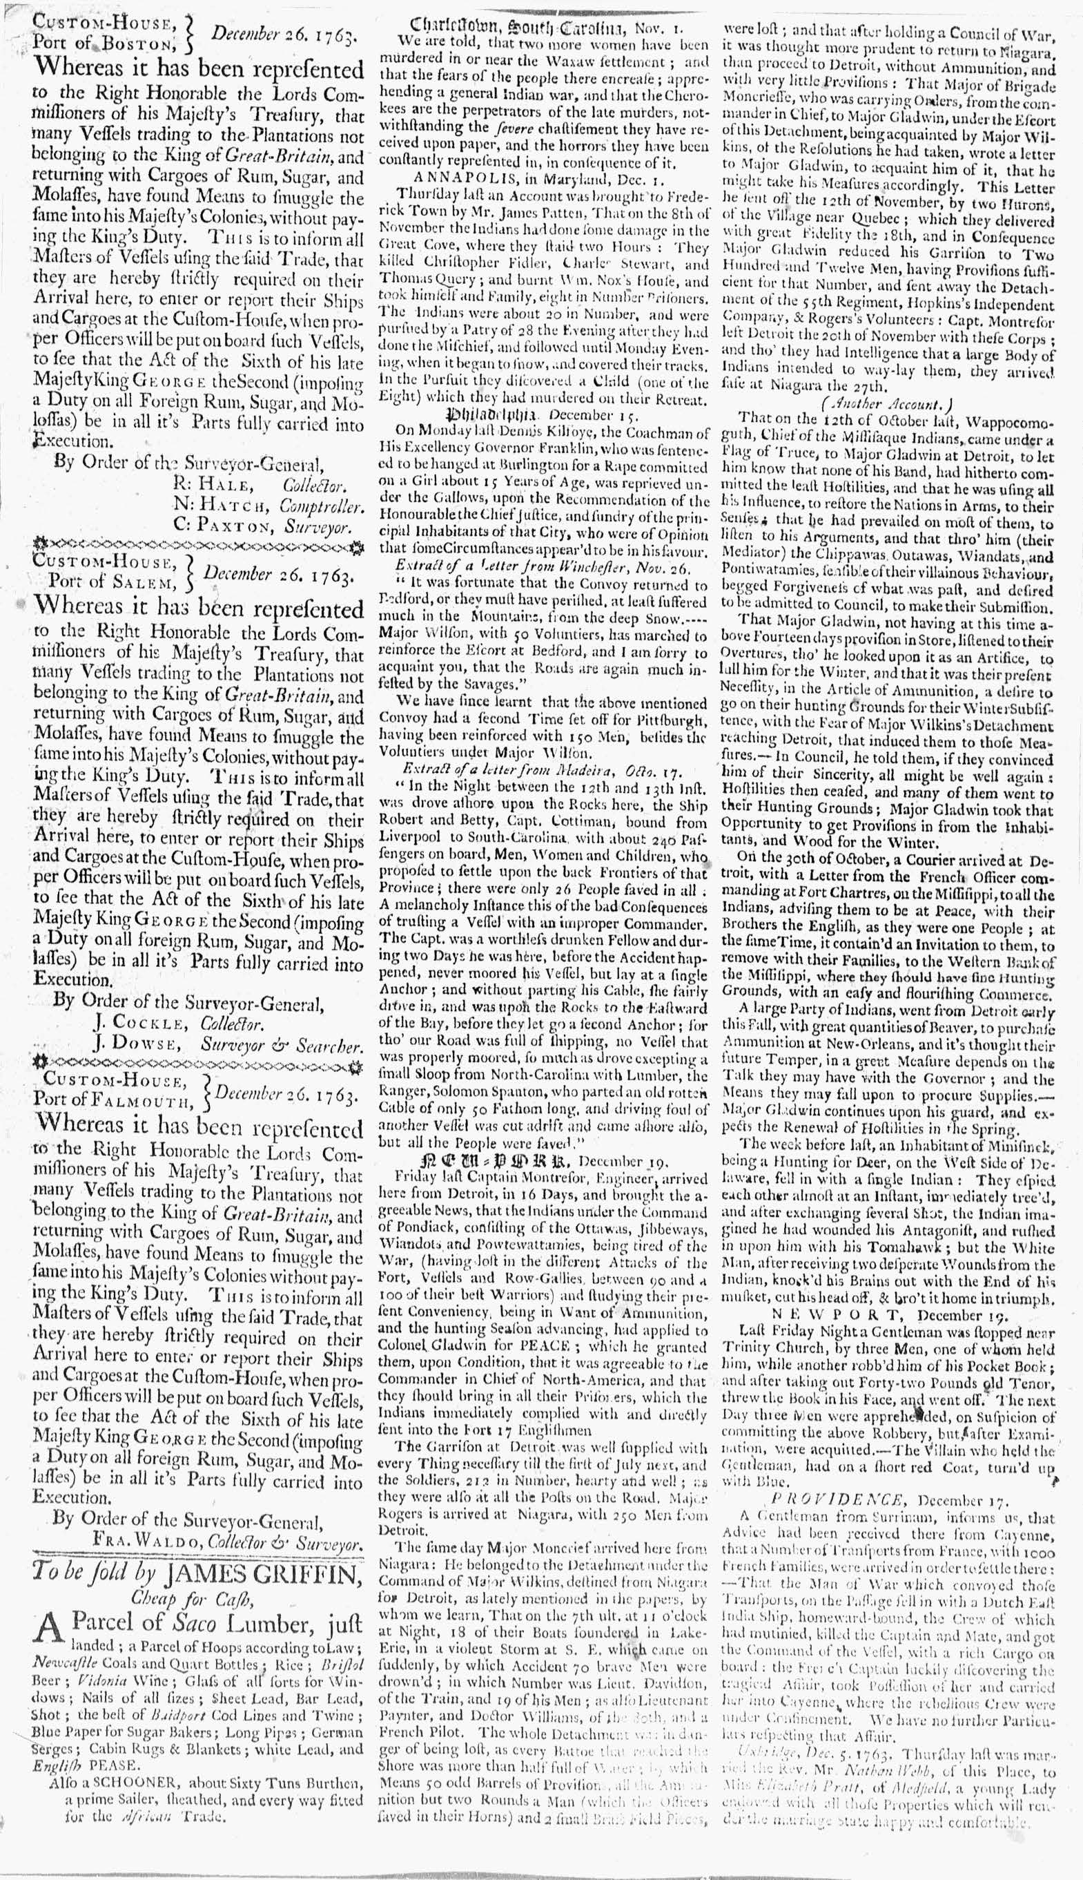

Image Source
“The Boston Evening Post.” January 2, 1774. Courtesy of Readex: America’s Historical Newspapers. Early American Newspapers, Series 1: From Colonies to Nation.

Document C

112 Gallons of Rum to Hannah Pratt
Original Transcription
Richard Derby was a Salem merchant, ship owner, and owner of a rum distillery in Salem. This is a receipt of rum purchased and received by Hannah Pratt. Pratt owned and operated a well-known tavern in Salem, the Blue Anchor in Town House Square. Pratt inherited the tavern from her mother, widow Margaret Pratt.
Following the death of a husband, 18th century women gained a new level of economic freedom and responsibility. They had the power to hold and manage their own property and earnings. But some widows became working women out of necessity to support themselves and their families. Many were licensed to sell alcohol and did so from their homes, shops, or even outside as a form of “poor relief.” Some gained significant success, owning and operating popular public taverns.

Salem Nov^{r}. 27th 1762
Han^{h} Rec^{d}. of Rich^{d}: Derby 112 Gallº Rum the Excise of
Pratt which I am to be Accountable for being a Licensed
Person in Salem in the County of Essex. Hannah Pratt.

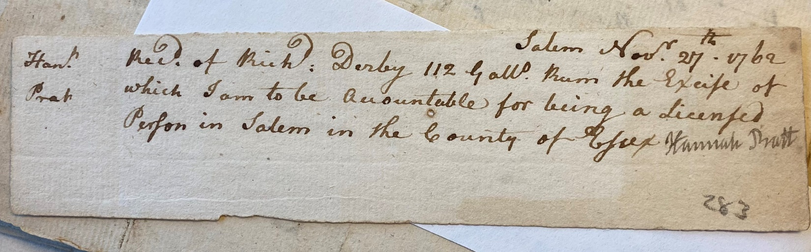

Image Source
MSS 37 Derby Family Papers, Box 14, Folder 9. Philips Library, Peabody Essex Museum, Salem, Mass. NPS Photo.

